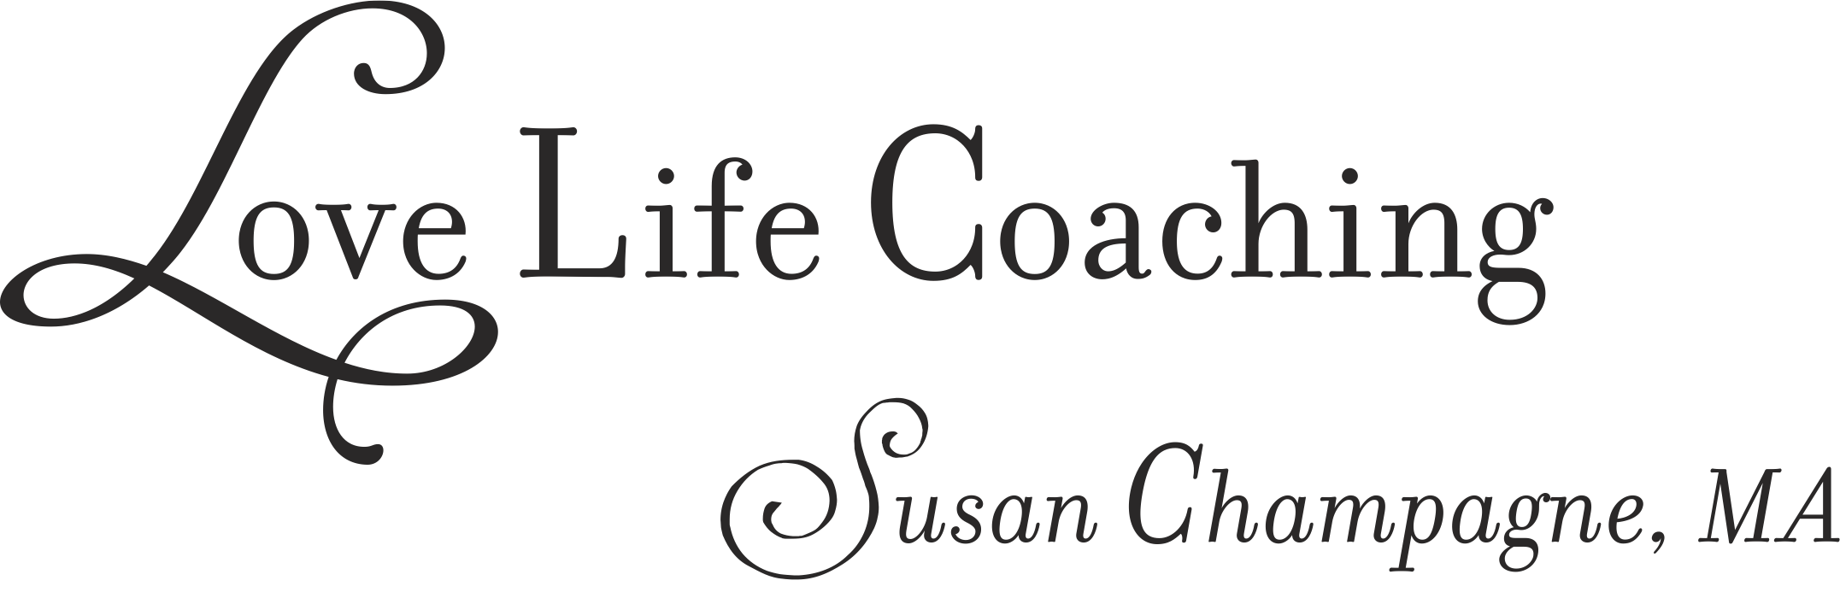

COACHING PROVIDES A VEHICLE FOR CREATING A LIFE
OF HEART AND PURPOSE

~ I help you to identify where you are stuck and how to deeply
align with your life’s vision and goals.

I specialize in a holistic
perspective on:

Relationship Issues * Life Transitions *Health and Well-Being

I have been involved in the Healing Arts for more than 25 years. I was certified as a Yoga Teacher in 1983, and earned my master’s degree in Transpersonal Counseling Psychology in 1990. I come to the innovative field of Life Coaching after having served a highly diverse clientele as a psychotherapist for over 15 years. I have taught Transformational Dance classes for women and non-secular meditation classes to men and women.

I have been a parent since 1981, and have run my own business since 1990. I am a passionate lover of music and the great outdoors.

You can review my website to learn more about me, and the services I offer.

I look forward to supporting you on this great adventure called YOUR LIFE!

